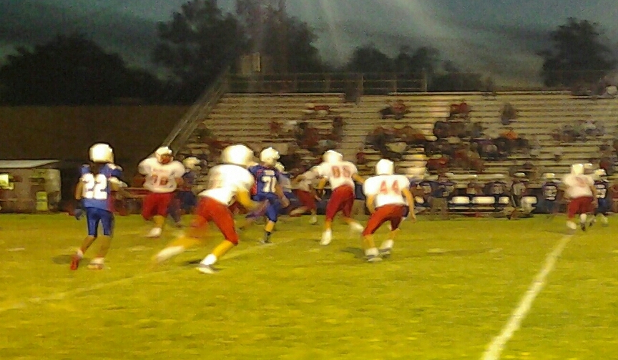

**YOUR HEADLINE IS HERE**

*THE*

**BULLPEN**

“Live as if you were to die tomorrow. Learn as if you were to live forever.”– *Gandhi*

**Main Events**

The main event this month is the homecoming dance. The dance is on October 2nd. It is located at St. John’s Lutheran. Other events include a pep rally on October 1st. So grab your jersey and bring your brahma pride and Cheer on Bellville as they take on Royal. Another event is on October 7th. Students at Bellville Junior High will be released early at 12:00. On October 8th and 9th there is no school due to the fair.

Our BJHS football season has started off extraordinarily thanks to the help of our two new coaches Coach Lewis and Coach Griffin. Although we have had injuries early, we have managed to win games. During the game against Wharton, Austin (Slushee) Leuschner had two interceptions and one fumble recovery. Our newspaper staff could see him as player of the week! –Will and Joseph

**THE TREND**

The new trend so far has been people wearing Joggers. Everywhere you look its joggers, joggers, and joggers. Also girls and boys are wearing Converse wherever I look every girl and boy is wearing Converse. I think I’m going to have to get some for myself.

**–Ian Alvarez**

YOU’RE TITLE HERE

Lorem volumus blandit cu has.Sit cu alia porro fuisset.

Ea pro natum invidunt repudiandae, his et facilisis vituperatoribus. Mei eu ubique altera senserit.

**INSERT YOUR ARTICLE TITLE HERE**

**INSERT YOUR ARTICLE TITLE HERE**

Ea pro natum invidunt repudiandae, his et facilisis vituperatoribus. Sed ut nunc adipiscing leo porttitor pharetra. Nam dictum. Mauris eu eros. Aenean vulputate dolor quis felis. Etiam accumsan adipiscing massa. Nunc pharetra tortor a odio. Nullam molestie justo. Maecenas eget nunc. Nunc pellentesque aliquam magna. Suspendisse ultrices sodales orci. Vestibulum dolor dui, viverra sit amet.

**PIC**

**In libris** graecis appetere mea. At vim odio lorem omnes, pri id iuvaret partiendo. Vivendo menandri et sed. Lorem volumus blandit cu has.Sit cu alia porro fuisset.

Ea pro natum invidunt repudiandae.

**PIC**

**In libris** graecis appetere mea. At vim odio lorem omnes, pri id iuvaret partiendo. Vivendo menandri et sed. Lorem volumus blandit cu has.Sit cu alia porro fuisset.

Ea pro natum invidunt repudiandae, his et facilisis vituperatoribus. Mei eu ubique altera senserit.

Ea pro natum invidunt repudiandae, his et facilisis vituperatoribus. Mei eu ubique altera senserit, consul eripuit accusata has ne. Ea pro natum invidunt repudiandae, his et facilisis vituperatoribus. Sed ut nunc adipiscing leo porttitor pharetra. Nam dictum. Mauris eu eros. Aenean vulputate dolor quis felis. Etiam accumsan adipiscing massa. Nunc pharetra tortor a odio. Nullam molestie justo. Maecenas eget nunc. Nunc pellentesque aliquam magna.

Krystal Rettig

**Carson Stark**

**Charlie DuBas**

**Justin Hulsey**

Charlie DuBas is in theater arts. His favorite color is also blue. He has 3 dogs, Darsey, Libby and Cailean, He has a cat. In his free time he Youtubes.

She’s a teacher because enjoys working with kids.

Her husband is Aaron Rettig, who’s our Band Director. Her future goal is to raise her daughter correctly. She graduated from SHSU with a bachelor degree. Loves Sam Houston; went to Bellville High school. She has 2 dogs and 2 cats.

Justin Hulsey’s favorite color is blue and he enjoys playing video games. He also has a dog named Ocho. Justin is an office aide.

Carson Stark’s hobbies include Youtubeing and playing video games. His favorite color is red and

He does cross country.. He plays the saxophone in the band. Eevee and

Dede are his 2 cats.

